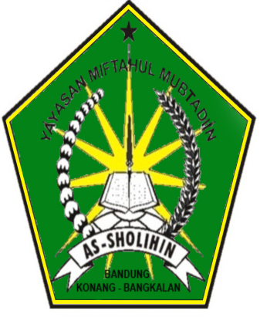

**DAFTAR PESERTA KELAS 8**

**UJIAN AKHIR SEMESTER (UAS) GANJIL**

**MTs . BAHRUS SHOLIHIN**

**TAHUN PELAJARAN 2017-2018**

**ASAL SEKOLAH : MI IBNU DAHLAN CANGKARMAN**

**88-088-001 S/D 88-088-012**

|  |  |  |
| --- | --- | --- |
| NO. PESERTA | NAMA SISWA | KELAS |
| 88-088-001 | Wahyu Ningsih | 8 |
| 88-088-002 | Solihin | 8 |
| 88-088-003 | Uswatul Hasanah | 8 |
| 88-088-004 | Rohmania Ramadani | 8 |
| 88-088-005 | Mutammimah | 8 |
| 88-088-006 | Miftahul Hasanah | 8 |
| 88-088-007 | Izetul Mardiyah | 8 |
| 88-088-008 | Buhori | 8 |
| 88-088-009 | Rana Rani | 8 |
| 88-088-010 | Zainul Bahri | 8 |
| 88-088-011 | Ridoi | 8 |
| 88-088-012 | Suid | 8 |

**88-088-015**

**88-088-014**

**88-088-013**

**88-088-009**

**88-088-010**

**88-088-011**

**88-088-012**

**88-088-008**

**88-088-007**

**88-088-006**

**88-088-005**

**88-088-001**

**88-088-003**

**88-088-002**

**88-088-004**

**PINTU MASUK**

**PENGAWAS RUANG**